**16. Named Entity Recognition (NER) Using SpaCy**

**Aim:**  
To perform Named Entity Recognition (NER) using the SpaCy library.

**Algorithm:**

1. Install and import SpaCy.
2. Load a SpaCy language model.
3. Process the input text using the model.
4. Extract named entities and display them.

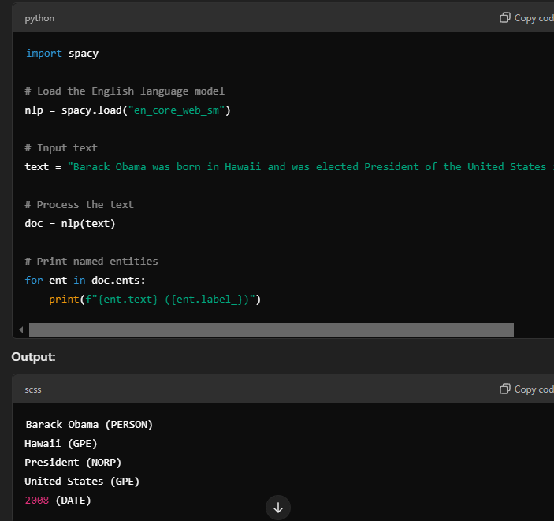

**Result:**  
Named entities are successfully recognized and categorized.